UACE MOCK EXAMINATIONS 2016

GEOGRAPHY

PAPER 1

TIME: 3 HOURS

***Instructions to candidates;***

This paper consists of three sections; A, B and C

Answer four questions only

Section A is compulsory.

Answer **one** question from section **B** and **one** question from section **C**

Credit will be given for use of relevant diagrams and specific examples.

Any additional questions attempted will not be marked.

**SECTION A:**

Questions 1 and 2 are compulsory

1. Study the 1:50,000 UGANDA Map extract of APOKA, sheet 9/3 and answer the questions that follow;
2. (i) State the physical feature found at grid reference 654976; (1 mark)

(ii) Account for the physical feature identified in (a) (i) above (4 marks)

1. Draw a cross section of the area along northing 11 from Easting 66 to Easting 74 and on it mark and name;
2. ridge
3. lowland,
4. river lotipe,
5. boundary
6. dry weather roads (8 marks)
7. Determine the
8. Bearing of Amobwasi (Kaluduko) trigonometrical station (grid ref 746121) from the air photo principle point at Kareki (grid reference 809092)

(2 marks)

1. Trend of the all weather road bound surface from Apoka trading centre to Kaabong. (2 marks)
2. Vertical interval on the map extract (2 marks)
3. Describe the relationship between relief and landuse types shown on the map extract.

(6 marks)

1. Compulsory photograph question.

Study the photograph provided and answer the questions that follow;

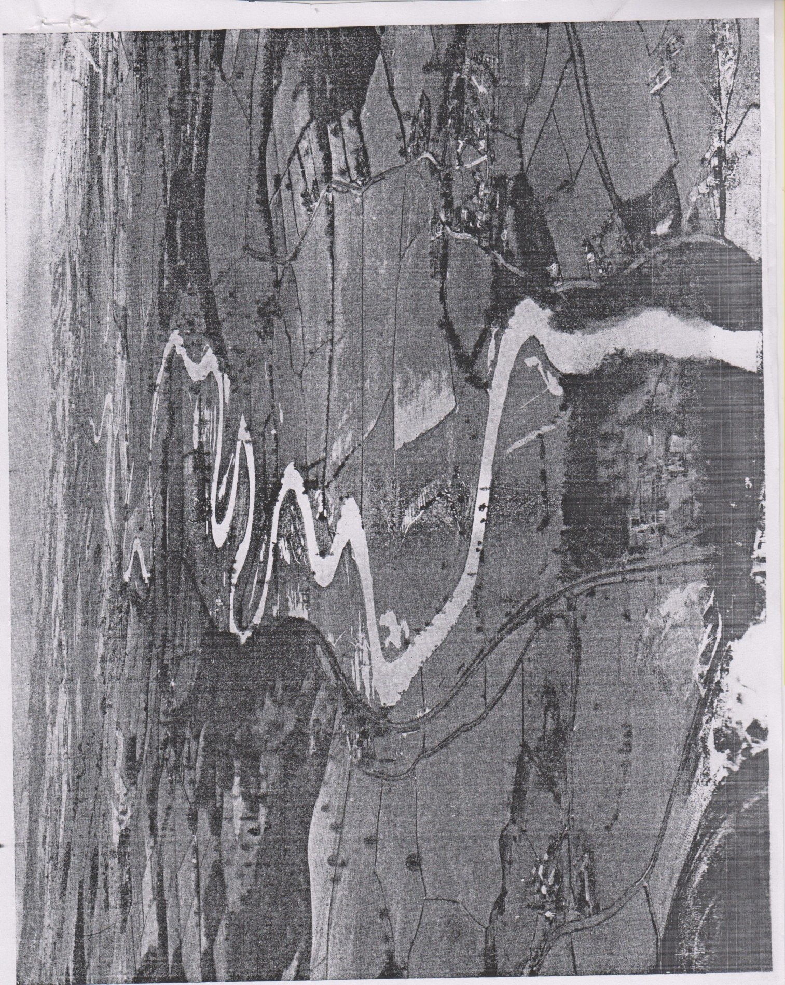

1. Draw a landscape sketch of the photograph given and on it mark and name;
2. Landuse types
3. Drainage feature. (8 marks)
4. (i) Describe the characteristics of the drainage feature shown in the photograph. (3 marks)

(ii) Explain the conditions that have led to the characteristics identified in (b) (i) above

(4 marks)

1. Giving evidence from the photograph, explain the importance of the drainage feature shown in the photograph (6 marks)
2. (i) Name the type of photograph given (1 mark)

(ii) Giving reasons for your answer, suggest one area in East Africa where this photograph could have been taken. (3 marks)

**SECTION B:**

1. Examine the influence of tectonic movements on the drainage of East Africa. (25 marks)
2. (a) Distinguish between sedimentary and metamorphic rocks (8 marks)

(b) Explain the influence of sedimentary rocks on landform development in East Africa

(17 marks)

1. Account for the formation of glacial erosional landforms in East Africa (25 marks)

**SECTION C:**

1. (a) Distinguish between Katabatic winds and anabatic winds (6 marks)

(b) Explain the influence of winds on the climate of East Africa (19 marks)

1. Account for the variation in natural vegetation zones on any one Mountain in East Africa

(25 marks)

1. To what extent does laterization explain the process of soil formation in East Africa (25 marks)

*END*